CRS testing environment
For testing CRS application we are using Hudson and Selenium.
Selenium is a set of tools that support development of test automation for web-based application.
Hudson is a build Server that is responsible for checking if application need building, building it, triggering defined tests and reporting on the state of the build.
To integrate Hudson with Selenium we are using Selenium Grid Hudson plugin.
How it works:
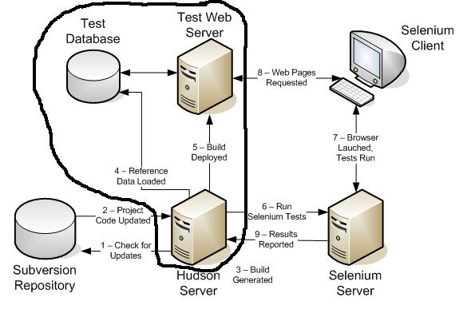
- Hudson check our Subversion repository if anyone has committed any changes
- If they have , it updates the project from Subversion and builds it using maven tasks
- It then create a clean version of our application database, loads in test data and deploys the application (currently test database, test application are on Hudson server but we will change it to make it as on screen above)
- A maven job is triggered that runs through a series of test in a remotely-controlled web browser on the fresh application
- Screenshots of the browser are taken for all pages of the site for later checking by a human(if tests fail)
- If any of the test fail, the developers responsible for the changes are notified by email of the problems

